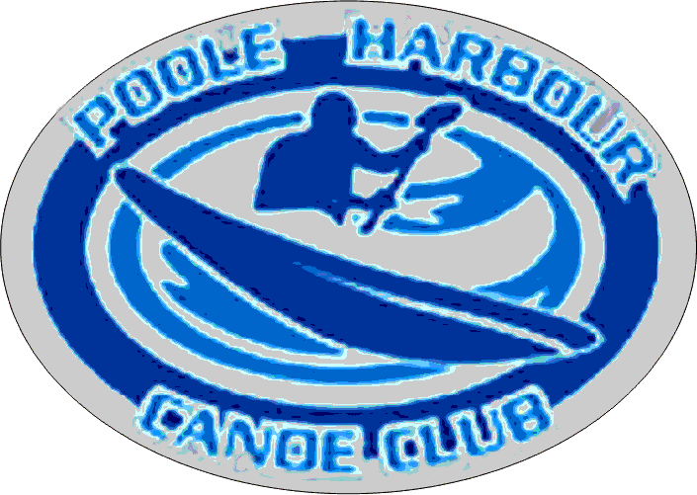

**Skills required for the BCU One-Star Award**

**Personal Paddling Skills**

**Lift, carry and launch**

Adjust the seat and footrests if possible.

If at all possible, adjust the foot rests. Some boats allow the foot rests to be moved while you are sitting in them, but most need to be adjusted on dry land before you get in.

Some boats allow the seat position to be adjusted, but it is worth adjusting the seat back if possible. A firm seat back will encourage a more upright posture and reduce the strain on your back.

The position of the seat and the foot rests should make the boat feel "snug" without cramping your legs.

Assess the bank / shore and access area to identify any dangers and risks.

At the bank or shore, watch out for icy, muddy or slippery surfaces – weed covered rocks, etc.

On a river bank, watch out for muddy slopes, mossy rocks, low branches, brambles, tree roots and also barbed wire and – very often - lengths of fishing line.

Lift the boats safely.

Work in pairs for a kayak or 3-4 for an open canoe.

Talk to the others so you know where you are going before you start. Agree who is doing what.

Keep your back upright and straight and use your legs to do the actual lifting.

When access to the water is risky, it may be better to form a human chain and slide the boats to each other - rather than everybody carrying their own.

Be careful too if it is windy as a kayak can easily act like a sail. Be aware of others and the end of your boat. Be aware of cars and buildings.

Get into the boat safely.

Work in pairs whenever possible.

The first person onto the water can steady the boat for the second person.

You can also use your paddle to steady the boat as you get in.

Keep your weight on the bank as late as possible. Keep your weight central in the boat.

*Start in pairs, but note that the syllabus does require you to manage this on your own.*

**Forward paddling**

Hold the paddle correctly.

Hands are only slightly further apart than your shoulders.

Your right hand (for right-handed paddlers) stays in the same place.

The right blade is at a right angle to your forearm.

Your right hand twists the paddle - the left hand lets the paddle twist.

Good upright posture.

Long stroke, starting with the blade well forward.

Turn your upper body to get that long reach.

Unwind the rotation in your upper body to give power rather than just pulling with your arms.

Look where you want to go - the boat tends to follow.

Steer via sweep strokes.

Keep the blade just under the water with the arm nearly straight.

Keep the shaft of the paddle low across the boat.

Sweep the blade in an arc towards the back of the boat amd exit just past your hips.

The first part of the sweep strokes pushes the bow away from the paddle, the end of the sweep stoke pulls the back of the boat towards the paddle.

(Introduce stern rudder)

A stern rudder is only of use when the boat is already moving forward.

Hold the paddle parallel to the boat, then lower the blade at the back into the water.

Pulling the lower end of the paddle will pull the back of the boat towards the paddle.

Pushing the lower end of the paddle will push the back of the boat away from the paddle.

If the paddle blade is initially over any part of the boat the kayak cannot travel in a straight line

**Steering and controlling**

Steer the boat (with sweeps and rudders) around a course while maintaining forward movement.

Reverse paddling to a fixed target. Safe looking behind. Correct paddle grip. Good body rotation.

Stopping should be with short dynamic strokes on both sides, so that the boat remains balanced and under control.

Rotate the boat on the spot, in both directions, using forward and backward sweep strokes - turning the body to give power to the sweep.

**Return to the bank and get out**

Assess the bank and exit area to identify any dangers and risks.

Manoeuvre to the bank

Get out of the boat safely.

Lift the boat out of the water safely.

**Rescue Skills**

**Capsize and be rescued or swim to shore**

Demonstrate control during a capsize by banging on the bottom of the boat - three times. Exit the boat. Collect the paddle and tow the boat to the bank.

Leave the kayak upside down - the air stays inside and helps the boat to float.

Tow the kayak by the handle/rope at the end.

Swimming on your back makes the towing easier.

(It is very useful to be aware of the techniques of deep water rescues)

**Emptying boats**

Lift and empty the boats safely.

**Safety, Leadership and Group Skills**

**Personal Risk Management**

What to wear.

What to take.

**Awareness of others**

Keeping others safe.

Understand the basic signals.

**Theory**

**Equipment**

Check your clothing before you start.

Will you be warm enough?

It is generally rather easy to cool down if you are too warm!

It is much harder to warm up if you are too cold.

Avoid cotton and wool.

Wear several thin layers rather than one thick one:

Inner layer - leggings and a ‘t-shirt’, base layers or thermals.

Middle layer - a fleece

Outer layer - a windproof jacket or cagoule

Maybe wear a hat - but choose one that you don't mind losing.

Ideally don’t wear shoe laces (they may have long loops that could catch on something?

If you are wearing glasses, are they secured? A strap is easy to fit ( or a short tape

Check your kit before you start.

Is your buoyancy aid zipped and clipped? Is it tight enough? Can somebody else lift it off you?

Should you be wearing a helmet?

Do you need some food with you?

Have you got something to drink?

Do you need sun protection?

Check your boat before you start.

Is the boat damaged? Are the handles secure?

Is the bung in?

**Safety**

Check the weather before you go.

Where to find weather information.

Check the skill needed to undertake trip.

Paddle in a group.

Manual handling issues - lift with your legs and keep back straight.

Are there any possibilities of getting trapped

Common injuries for paddlers.

Be aware of > Infections, algae and [leptospirosis](http://towerhamletscanoeclub.co.uk/wiki/Leptospirosis).

**First Aid and Hypothermia**

Know the signs of hypothermia. What should you do?

**Access**

Where can you paddle?

Where do you need a licence?

How can you get a licence?

Where can you paddle without a licence?

Difference in [access](http://towerhamletscanoeclub.co.uk/wiki/Access) rules between Scotland and England

**Environment**

Country Code - Litter, gates etc.

Erosion

Wildlife

**General**

What is the BCU? What does it do?

Edited : Bill R August 2015 for: [www.poolehrabourcanoeclub.uk](http://www.poolehrabourcanoeclub.uk)